**Exp. 2** **Design Christmas Dual Led Chaser Lights**

Circuit Diagram:

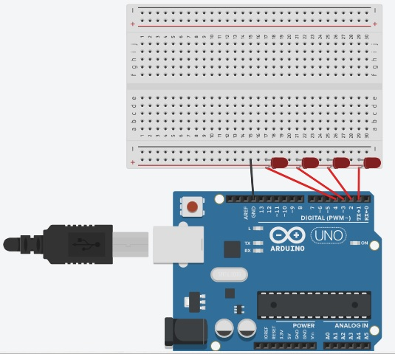

**Theory**

Concepts Used:

1. Working of Arduino UNO
2. Circuitry of Breadboard and it’s use
3. Coding in Arduino IDE and syntax of the same
4. Working of LEDs (Light emitting diodes)
5. Making connections on a Breadboard.
6. For loop syntax and use.

Learning & Observations:

Coding in Arduino IDE: It’s a very systematical way to show how the circuit is working. Coding syntax is very similar to the coding in C language which we are being taught. I learnt the importance of calculated delay as the micro-controller is very fast and capable.

I observed that there are many other interesting functions, like random function is fun to use.

Problems & Troubleshooting

I had to take about 3 tries to find the right amount of delay so that the strip works one LED at a time and also without any significant delay in one LED turning OFF and the next LED turning ON.

Other than this I encountered no other issue.

Precautions

1. Remember to declare all the ports in use in digital input/output in the right way.
2. Check whether all your wire pieces are working correctly and all connections are good.
3. Remember to connect Negative end of device (in this case LED) to GND (ground) in Arduino Uno to ensure potential difference.
4. TRY to find right amount of delay by approximation and improvisation by trial so that the circuit performs at it’s best.

Learning Outcomes

Skills that I have acquired are sound knowledge of using Arduino UNO and a better idea of approximation by trial.

I can now perform these things easily.